**TUGAS ASSIGNMENT 2**

Nama : Adenia Adiresta

Nomor Peserta : NPRG001ONL008

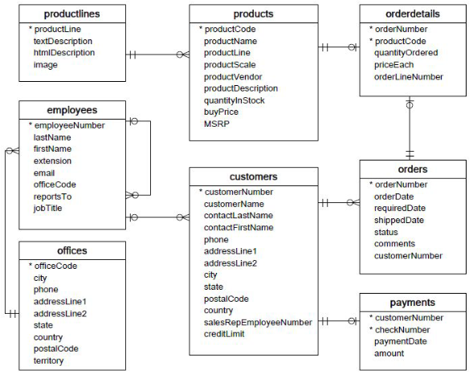

Field dan Tipe Data

1. Tabel Customer

|  |  |
| --- | --- |
| Nama Field | Tipe Data |
| customerNumber (PK) | Int |
| customerName | Varchar |
| contactLastName | Varchar |
| contactFirstName | Varchar |
| phone | char |
| addressLine1 | Varchar |
| addressLine1 | Varchar |
| city | Varchar |
| state | Varchar |
| postalCode | Char |
| country | Varchar |
| salesrepemployeeNumber(FK) - employees | Int |
| creditLimit | Varchar |

1. Tabel Orders

|  |  |
| --- | --- |
| Nama Field | Tipe Data |
| orderNumber(PK) | Int |
| orderDate | Date |
| requiredDate | Date |
| shippedDate | Date |
| status | Varchar |
| comments | text |
| customerNumber(FK) - customer | Int |

1. Tabel Employees

|  |  |
| --- | --- |
| Nama Field | Tipe Data |
| employeeNumber(PK) | Int |
| lastName | Varchar |
| firstName | Varchar |
| extension | Varchar |
| email | Varchar |
| officeCode(FK) - office | Int |
| reportsTo | Varchar |
| jobTitle | Varchar |

1. Tabel Office

|  |  |
| --- | --- |
| Nama Field | Tipe Data |
| officeCode (PK) | Int |
| city | Varchar |
| phone | char |
| addressLine1 | Varchar |
| addressLine1 | Varchar |
| state | Varchar |
| country | Varchar |
| postalCode | char |
| territory | Varchar |

1. Tabel Payments

|  |  |
| --- | --- |
| Nama Field | Tipe Data |
| checkNumber (PK) | Int |
| customerNumber(FK) - customer | Int |
| paymentDate | Date |
| amount | varchar |

1. Tabel Products

|  |  |
| --- | --- |
| Nama Field | Tipe Data |
| productCode(PK) | Int |
| productName | Varchar |
| ProductLine(FK) - productline | int |
| productScale | int |
| productVendor | Varchar |
| productDescription | Varchar |
| quantityInStock | Varchar |
| buyPrice | char |
| MSRP | Varchar |

1. Tabel orderdetails

|  |  |
| --- | --- |
| Nama Field | Tipe Data |
| orderNumber(FK)-orders | Int |
| productCode(FK)-product | int |
| QuantityOrdered | int |
| priceEach | Varchar |
| orderLineNumber | int |

1. Tabel productlines

|  |  |
| --- | --- |
| Nama Field | Tipe Data |
| ProductLine(PK) | Int |
| textDescription | text |
| htmlDescription | text |
| image | BLOB |

Screenshoot Query

1. Buat database bank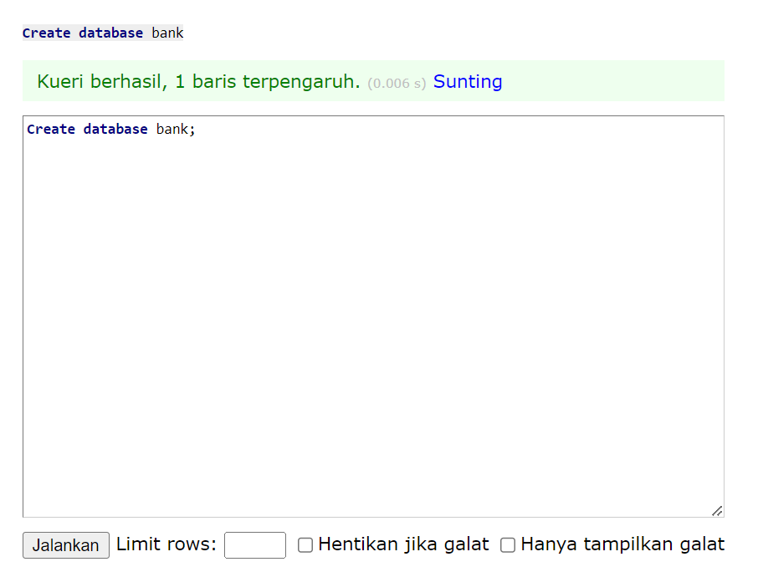
2. Buat table Customer

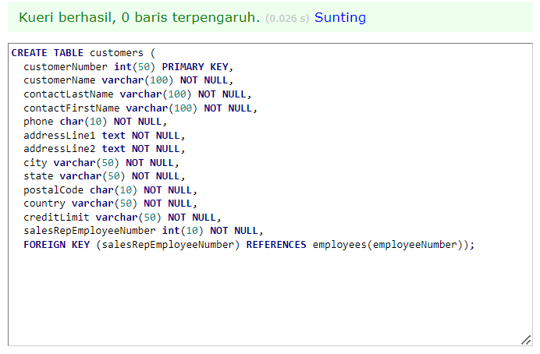

1. Buat table Products

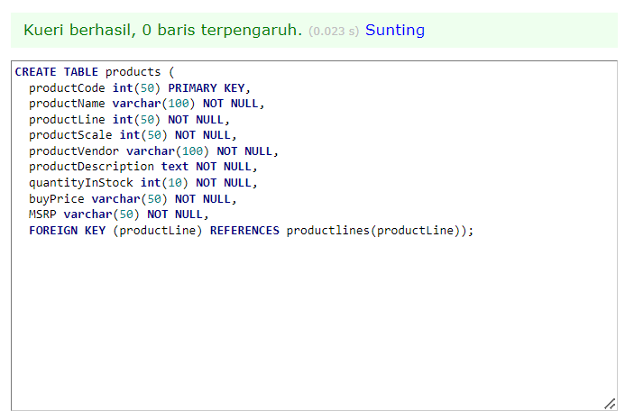

1. Buat table Productlines

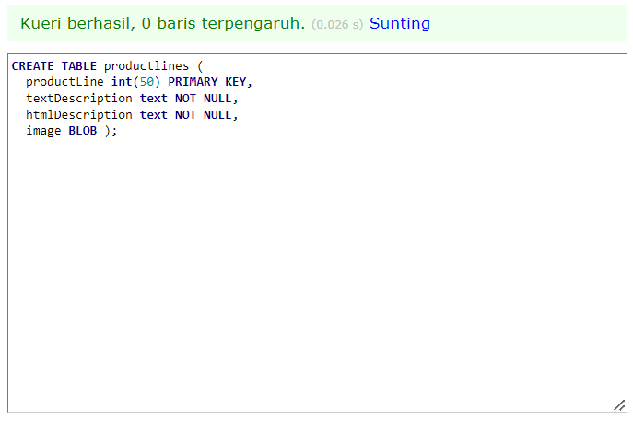

1. Buat table Orders

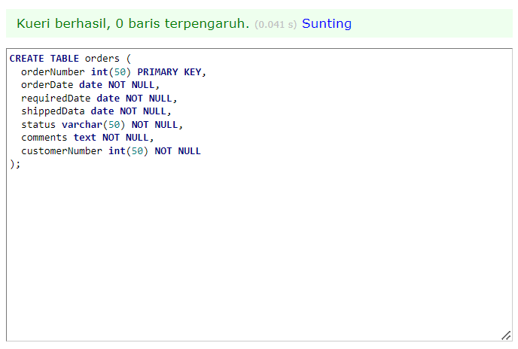

1. Buat table OrderDetails

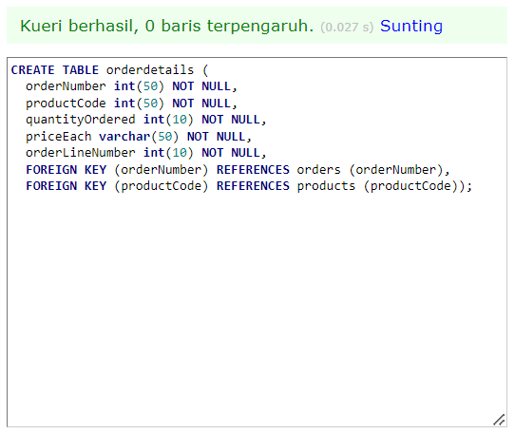

1. Buat table Payments

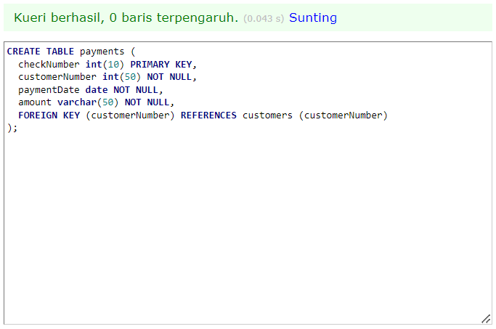

1. Buat table Employees

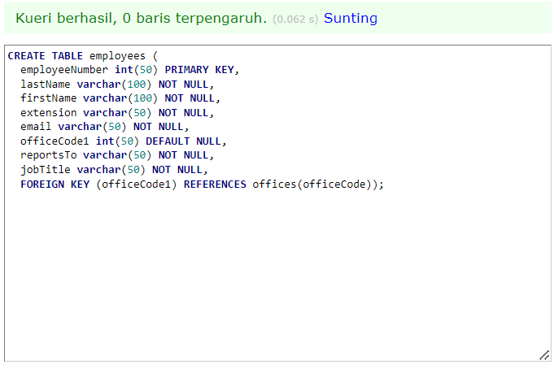

1. Buat table Offices

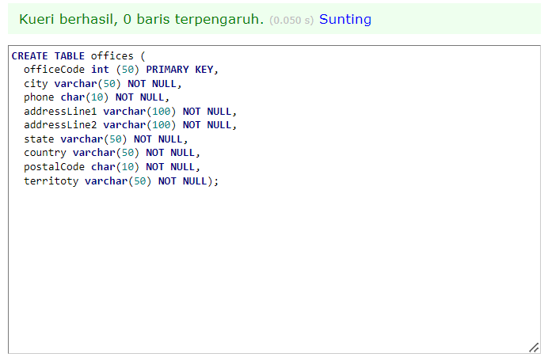

Output :

